**ECOLE CENTRALE DE LYON – CAR N°81**

**DESIGN REPORT**

# Design overview

Vulcanix is the name of the 2018 car of the Ecurie Piston Sport Auto team from Ecole Centrale de Lyon (France) planned to compete to the Formula SAE Italy. The aim of the design was to produce a vehicle to the following goals:

* Reliable with low maintenance
* A ready to drive and simple car for any driver
* Reactive vehicle, especially in corners
* All these qualities contained in a reasonable price

The resultant vehicle weight is 232 kg. The car is based on a tubular steel space-frame chassis, powered by a four-cylinder internal combustion engine combined with 13” tyres.

We structured the whole conception of our vehicle using the system engineering process. Starting from general specification, according to FSAE rules and time expectation for dynamic events, each team member developed his own specification for his subsystem. An iteration process has been done, in order to have viable designs that reach the specification. After, the mechanical design of each part was make using Catia. Then, following that phase of conception, the production of the parts started in compliance with the feature we set. Unit validation of each part has been done, to proceed to the integration and validation of the subsystems and finally the car was realised in order to confront its performances to the objectives announced.

# Vehicle dynamics, suspension and steering system

## Tyre choice

Thanks to the data of the Tyre Data Consortium and data processing, we were able to study the performance of 10" and 13" tyres available in the market. Regarding the team expertise and the friction coefficient in all the different conditions, the Hoosier 10" and 13" appeared as the best compromise. The final choice of the size of the tyre was a compromise between the mass reduction of the 10" and the gain in friction coefficient of the 13". A simulation of the car's acceleration led to the conclusion that the 13" were the best option. In addition, the larger space available in a 13" rim would allow us more flexibility for the suspension setup which confirmed our choice.

## Suspension

The suspension is first composed of non-parallel, unequal A-Arms. We take advantages of the flexibility that this architecture offers to set the parameters that determined the vehicle dynamics, first with a 2D model and then a 3D one on Catia. These models allow to position many parameters such as the roll centres, caster, or camber variation as expected. The camber variation is studied, to take the advantage of the 13” tyres adherence, particularly in corners. We have developed a process, experienced and applied it in order to build our own A-Arms made of rods in carbon fibre reinforced polymer glued to aluminium ball joint holder.

The whole shock absorber assembly has been aligned with the displacement plane of the wheel to avoid any non-linear effects and to simplify the geometry design with a 2D model to reach the desired motion ratio. Our springs have been chosen with ride frequency targets and adjustment have been made during trials to satisfy general driver style. To achieve the same goal, we used the Öhlins TTX25 mkII, 4-way damper, to complete the suspension system, as they offer a large possibility of adjustment.

## Steering system

The steering system has been designed to optimise tyre adherence, in order to allow the vehicle to pass through any bend (turning radius of 4m) and give a good driving response to the pilot. An Ackerman geometry has been preferred favouring sharp turns, with low speed behaviour. The geometry deals with other aspects of the car, such as the ergonomics (steering wheel size and position) and upright in order to remain consistent and comfortable for the driver.

## Wheels Assembly

The uprights were designed to fit to the design work on the suspension geometry, avoiding any interference. To help achieve this, the essential load cases (such as acceleration, braking and turn) were simulated using MecaMaster in order to design and optimise the structure which was a compromise between high resistance, small mass and processability. Both front and rear wheel assemblies were based on the same design principles. The static camber can be modified by shims and the toe set by adjustable rod lengths. The pre-load on the two angular contact ball bearings is applied with a bearing locknut at the front and the tripod housing at the rear. A washer has been inserted between the hub and one of the bearings to avoid stress concentration in the hub. We used strong 7075 Aluminium alloy for both the uprights and the hubs in order to have lightweight, yet resistant parts.

# Braking system

To ensure good braking performance and endurance, we chose competition brakes from Beringer composed of floating cast iron discs (230mm diameter) and dual piston callipers (32mm bore). These monobloc callipers give a compact design in the wheel assembly. This package is designed to give powerful and enduring braking under racing conditions. Two independent brake circuits were used: one for the front and one for the rear. A balance bar is used with the brake pedal in order to let the driver easily adjust the front and rear distribution to suit his driving.

# Frame and body

## Frame

For purpose of reliability and strength, we chose a tubular space frame design using AISI 4130 steel, with the main focus on stiffness and proper implementation of all subsystem of the car rather than weight. For instance, the mountings of the rear suspension have been set to have linear phenomenon and part in ‘tension compression’ despite having more tubing. Frame dimensions were created using adjustable parameters in order to quickly adapt to the evolution of other systems, especially the engine and suspension mounting points. The frame was analysed using Catia finite element analysis (FEA) built-in module in order to optimise the tubular structure. An iteration process between CAD and FEA, help to obtain an architecture for the triangulation and tubing diameter and thickness in order to reach a satisfying chassis stiffness regarding the rules and weight. The chassis stiffness was set to be at least 3 times the suspensions stiffness to avoid excessive distortion under high dynamic load. To have the desired suspension geometry and an easy engine integration, the car has removable bracings.

## Body

We chose to design a body which mainly covered the front of the vehicle up to the main hoop. The rear was kept exposed, in order to simplify the design and avoid collisions with the engine and drivetrain elements at the rear of the vehicle. The front part is mainly made of fibreglass, for cost reasons, and completed with small slabs. It can be easily removed in order to facilitate maintenance on the vehicle.

# Powertrain

## Engine choice

Considering our global design objectives, the criteria for the engine was for reliability, the available power and torque, the mass and dimensions. Although we initially considered using light and compact mono-cylinder or two-cylinder engines, we finally chose to use a powerful four-cylinder that would guarantee satisfaction for any driver in terms of engine response. Besides, the power to weight ratio will be better with a four-cylinder engine, even if a lighter engine could have allowed for a lighter design of other parts. The Honda CBR600RR was chosen because of its well-known solidity and its maximum power RPM which is lower than other models, meaning that the intake restrictor will have a lesser influence. In order to preserve its reliability, and easily accessible spare parts, we chose not to make major modifications to the engine. The original clutch, was replaced by an anti-dribble one in order to cancel engine braking effects and allow clutchless downshifting. Finally, the conception of a new flat wet sump has allowed us to lower the engine of 60mm and consequently the centre of gravity on the vehicle.

## Exhaust and intake air system

The intake and the exhaust systems were designed together to offer the maximum torque at 10000 rpm and to deliver a constant flow of power over a wide band of rpm in order to facilitate the drivability. The exhaust line has a 4-2-1 configuration, in order to facilitate the draining of the engine, and an acoustic study was made to establish the correct length of the exhaust. The line is made in stainless steel with a ceramic coating to lower the heat radiation, in order to allow a compact packaging. The intake system was designed to reach our performance goal by optimising the air flow, first with a manifold of revolution for an equal air-distribution between the four cylinders. The air intake system is build based on a throttle body with an inlet flange bought from AT Power, while the other parts mainly take advantage of rapid prototyping. The laser sintering technique allows complex shape made of Polyamide 12.

## Fuel system

A custom tank was created with a capacity of 7.5 litres, in order to finish off the whole endurance event. The fuel tank was designed to ensure a constant fuel supply even in bends, thanks to a false bottom working as a buffer volume.  This system is completed with a single fuel injector rail, kept in the original Honda location. One of the lightest fuel pumps available on the market supply the injector rail.

## Drivetrain

To avoid frequent gear shifts, the use of only three gears allows to take the best part of the engine from 0 to 100 kph. Therefore, the integrated transmission of the Honda engine was kept and the final drive ratio was chosen by simulation to improve acceleration. The power transmission is achieved by chain, which offers the possibility to easily change the drive ratio. A limited slip differential was chosen to improve traction during cornering and to limit understeering and tyre wear. The Drexler differential has been adopted for its small mass, and steel axles were chosen for their strength and resilience. An eccentric system made in polymer (Delrin) allows the whole differential to move longitudinally, in order to adjust the chain tension. The differential position was chosen to minimise tripod operating angle, taking into account wheel travel and chain tensioning.

## Electrical system

The electrical system was created around a DTAFast ECU as its software is very user-friendly and even beginner drivers could make adjustments to engine mapping and other functions. This ECU uses throttle/rpm injection and timing maps with compensation depending upon water temperature, air temperature, throttle transients and manages shift cut, launch control and traction control. A wideband lambda sensor enables closed-loop control if desired. The electrical systems around the ECU of the car has been separated in three different parts for reliability reasons:

* A rear electronic card, based around an Arduino to pilot the brushless servo-motor used as actuator for gear change. A closed loop ensure that every gear change is completed properly.
* An electric system avoiding the use of electronic (calculation unit) in order to start the engine and be able to drive in any situation. Therefore, the essentials are connected through a power cable. As a basic way of connection, the maintenance is easier, this also reinforces reliability.
* A front electronic card displaying only necessary information to the pilot such as gear engaged and tachometer. The information is transmitted through a CAN bus between ECU, rear and front electronic card to reduce the number of cables crossing the vehicle and also of that passing through the firewall. Important information (injection cut signal, shift palette) are still cabled apart from the CAN bus. A failure of this card would not be a crippling effect on the car functioning.

All electrical elements are fuse-protected and follow standards for vibration and protection against the environment. The wiring process has been carried out mostly outside the vehicle, on a bench following a pre-established wiring diagram. This helps to obtain a professional and clean electrical finish.

# Vehicle tuning and testing

## Robustness checks

Reliability being one of our main objectives, the first priority has been to test out the vehicle's resistance by performing tests. Low, medium and high-speed tests were first carried out, as well as acceleration, skid pad and autocross courses. Each test was followed by a thorough visual check of the vehicle, including the suspension.

## Driver training

In order to get the beginners used to the driving of a formula student car, sessions of training with a former vehicle of the team were organised. Then, when our car was ready, the pilots begin by getting used to the vehicle behaviour. The tracks of the acceleration, skidpad and autocross events were reproduced on private circuits to train the drivers to the behaviour of the vehicle in similar conditions to the competition. Quickly, the pilots were assigned to one or two specific dynamic events for the competition and each sessions of trainings focused on one particular dynamic event.

## Engine tuning

Before the testing sessions, target lambda maps were prepared according to the needs of each event. The overall goal was to obtain a lambda at 0.88 for maximum power, or 1.2 for maximum efficiency. The injection time maps were derived from these target lambdas and the lambda sensor data stored by the DTA S80 ECU.

During track tests, pilot feedback was used to adjust the transient speeds. The traction control and launch control were adjusted from the driver's tyre data and feedback, and the shift cut duration is optimised according to the behaviour of the geared motor, so as not to dry out the intake.

## Suspension tuning

First, we set the parameters of the car to theoretical needed values on a geometry bench. Then, the suspension was adjusted during trials, in order to have a vehicle behaviour satisfying the driver. To achieve this, we collected driver feedback, time on skidpad event, acceleration and autocross. Then we mainly adjust dampers and tyre pressure to equilibrate the car. A pyrometer is also used to adapt camber by adding or removing shims or modifying tyre pressure.

**Result**

**Validation**

**Design**

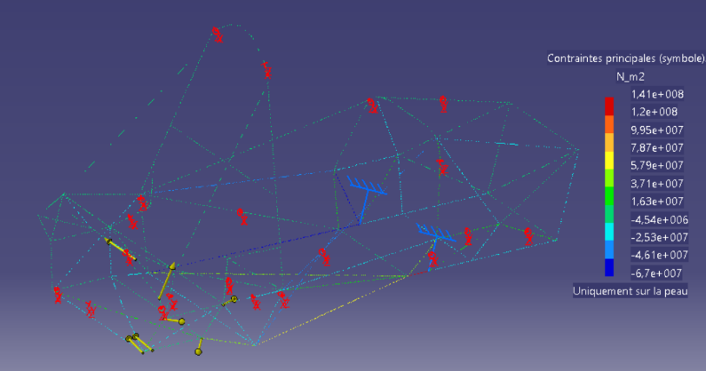

Figure 3: Simulation of the stress repartition in the chassis during a 2G left turn on the right rear wheel

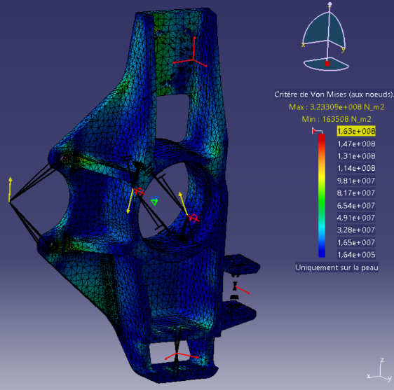

Figure 1: Simulation of the stress repartition in the upright during a 2G breaking

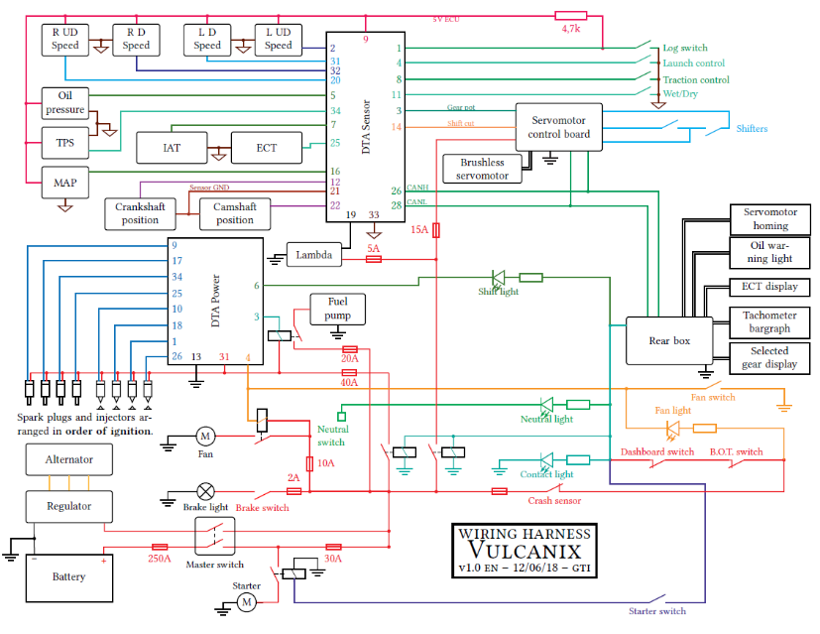

Figure 2: Wiring harness

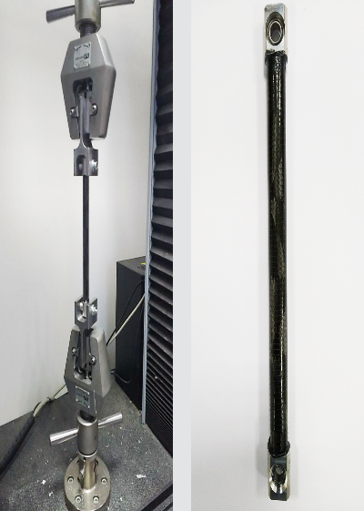

Figure 5: Traction test for A-Arms fabrication process validation

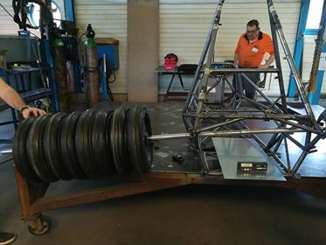

Figure 4: Experimental validation of the deformation model of the frame under torsion torque

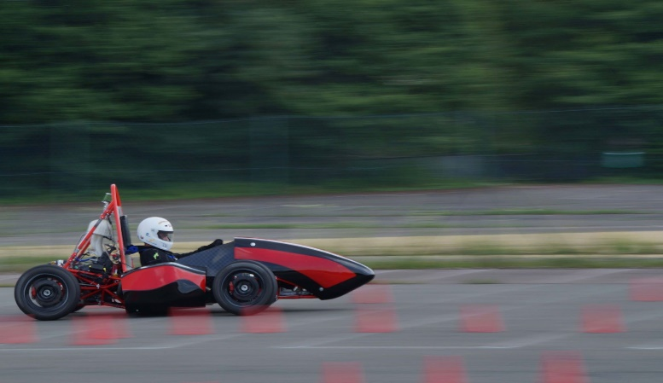

Figure 6: A testing session